🚀 STEP 1: Launch EC2 with Public IP
Go to:
AWS Console → EC2 → Launch Instance
Configuration
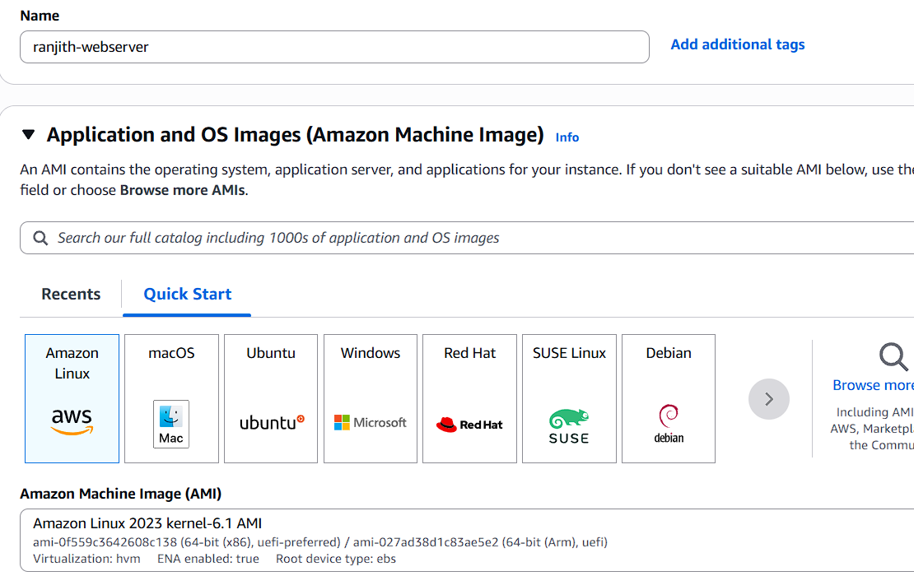

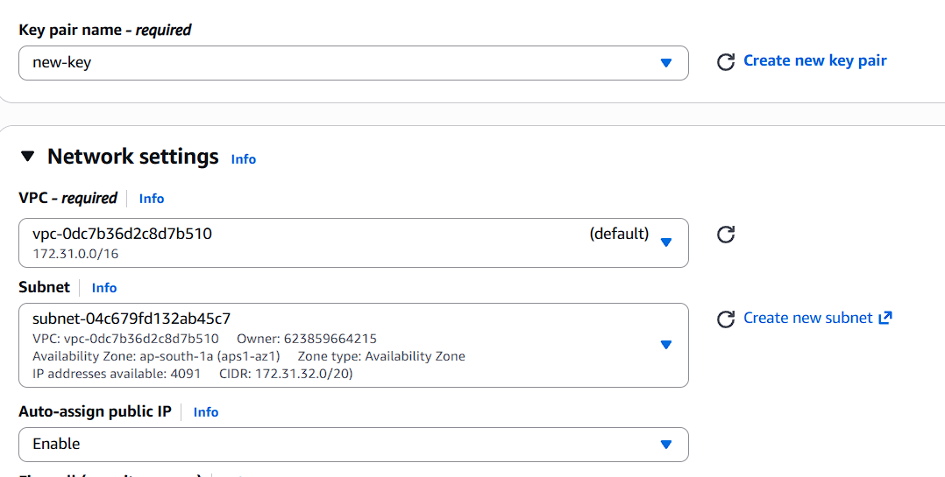

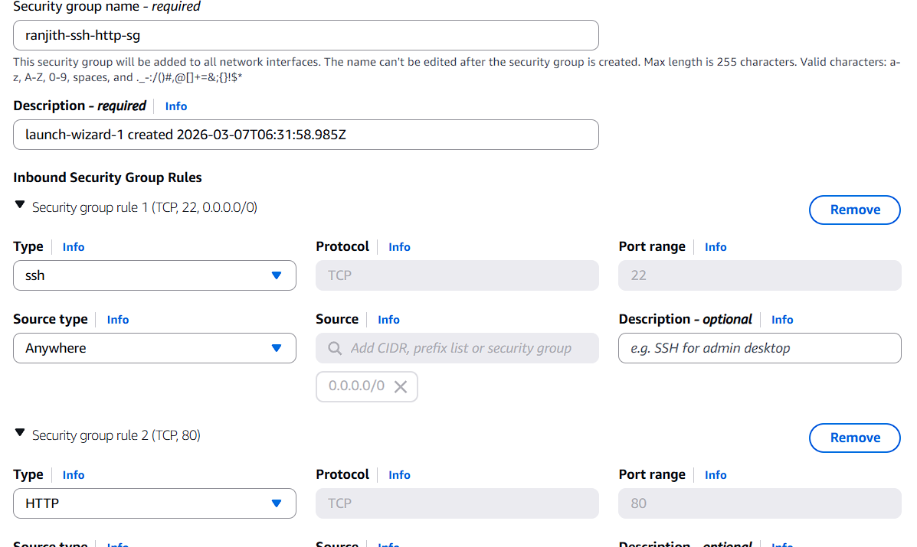

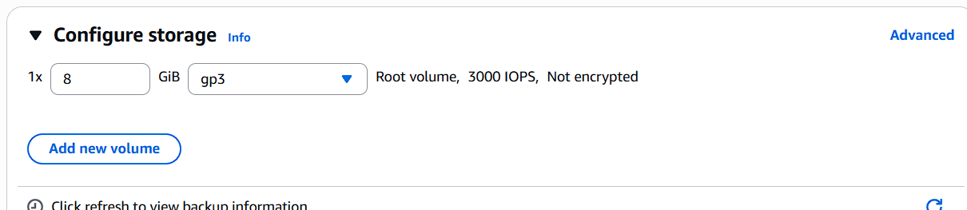

Click Launch
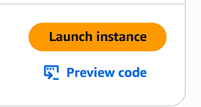

🔎 STEP 2: Check Public IP
Go to:
EC2 → Instances → student-vm
Note:
Public IPv4 address: xx.xx.xx.xx
Save this IP somewhere.
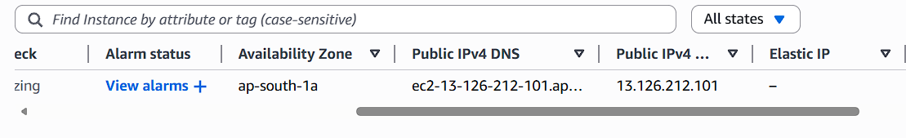

🔁 STEP 3: Reboot Instance
Select instance → Instance State → Reboot
Wait until status checks pass.

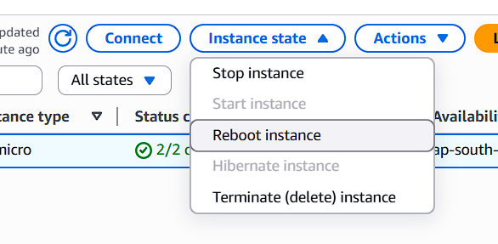
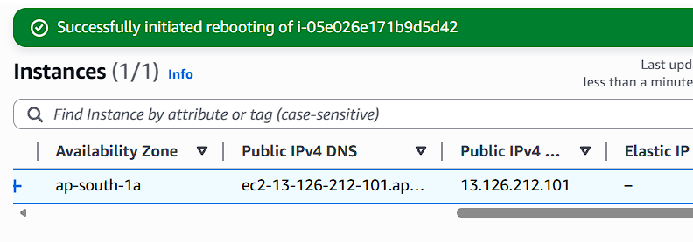
Now check:
👉 Is Public IP changed?
✅ Answer: NO
Reboot does NOT change public IP.

🔴 STEP 4: Stop and Start Instance
Now do:
Instance State → Stop Wait until stopped

Then:
Instance State → Start
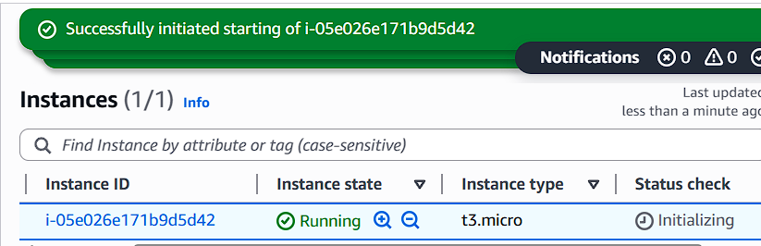
After instance is running → Check Public IP again.
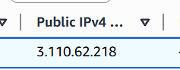

❓ Did Public IP Change?
✅ YES
When you Stop & Start, AWS releases auto-assigned public IP and assigns a new one.

📌 Observation Table
Action | Public IP Changes?
Reboot | ❌ No
Stop & Start | ✅ Yes

🌐 Why This Happens?
Auto-assigned public IP is temporary. When instance is stopped → IP is released.

🔒 STEP 5: Allocate Elastic IP
Go to:
EC2 → Elastic IPs → Allocate Elastic IP
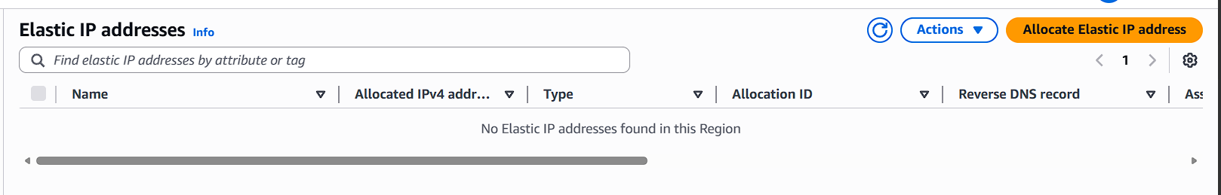
Click Allocate

Name it:
student-eip
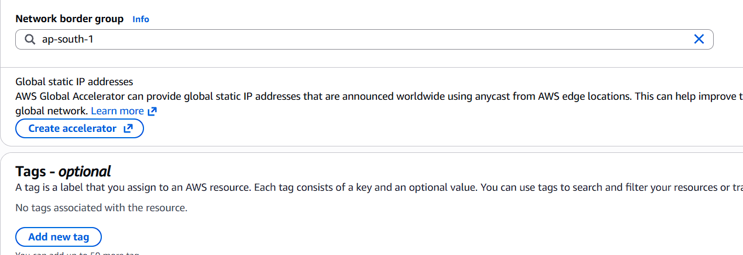

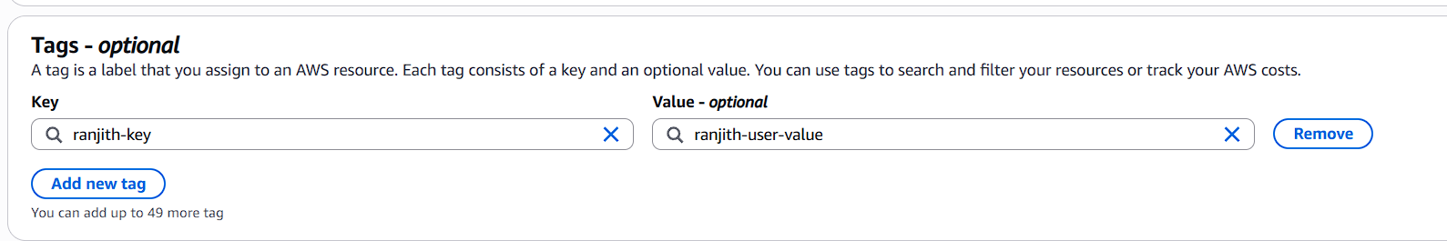

🔗 STEP 6: Attach Elastic IP
Select Elastic IP → Actions → Associate Elastic IP
Choose:
- Resource Type → Instance
- Instance → student-vm
- Private IP → Default
Click Associate
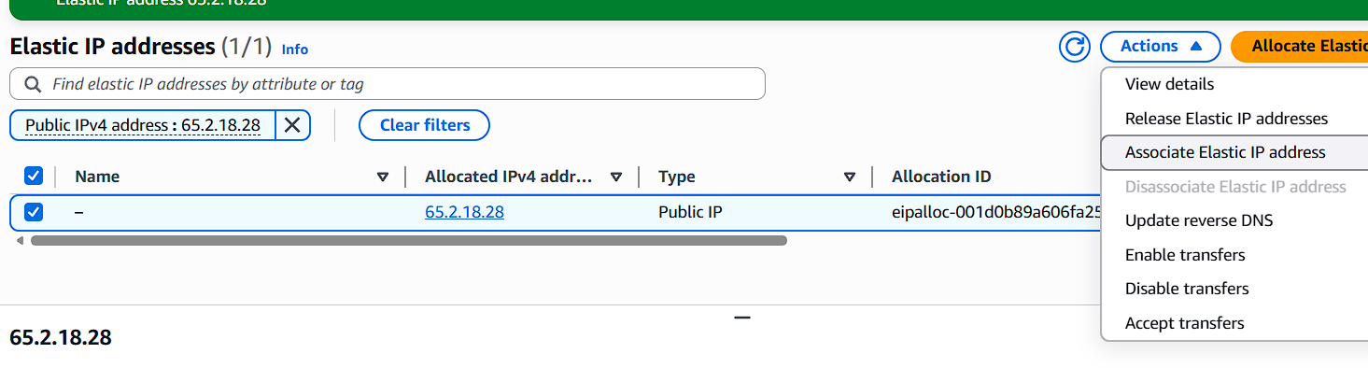
Now check instance → Public IP
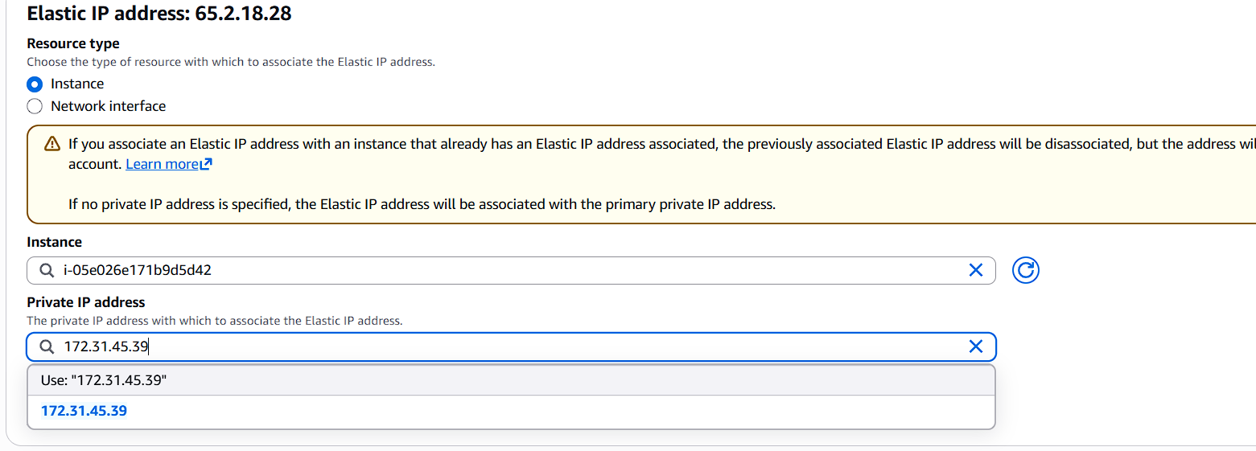

It should now show the Elastic IP.

🔁 STEP 7: Reboot Instance
Reboot instance again.
Check Public IP.
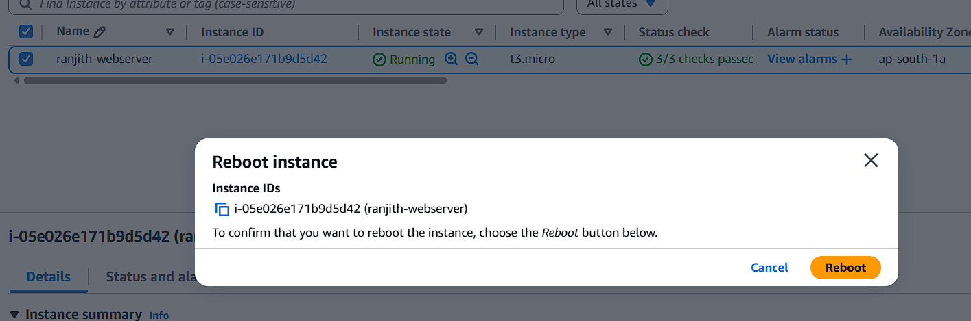

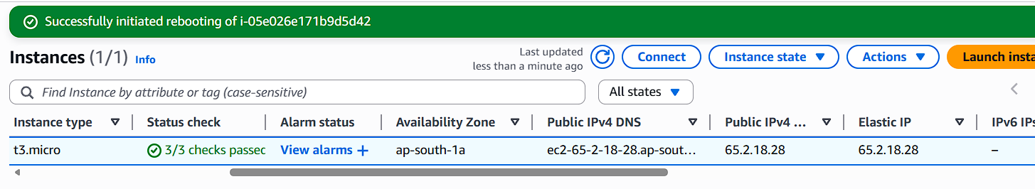
✅ Elastic IP remains SAME.

🔴 STEP 8: Stop & Start Again
Stop instance Start instance
Check Public IP.
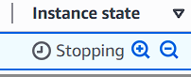

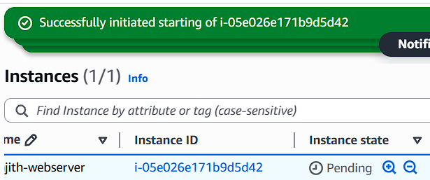
✅ Elastic IP remains SAME.
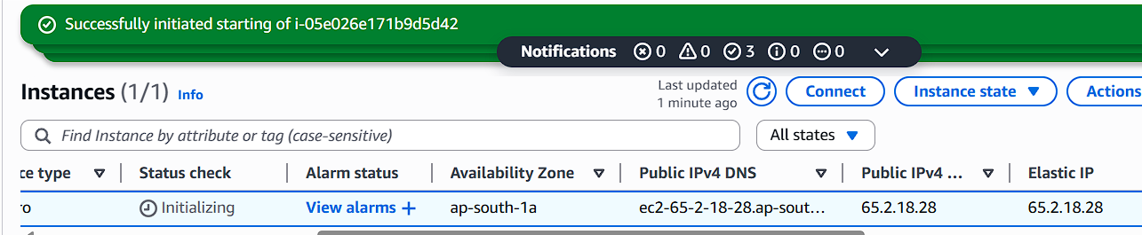

📊 Final Validation Table
Scenario | Auto Public IP | Elastic IP
Reboot | Same | Same
Stop/Start | Changes | Same
Recommended for Production | ❌ No | ✅ Yes

